

### A Synopsis Report

ON

PET FEEDER BASED ON ARDUINO UNO

## BY

1. Harsh Dobariya T4/572
2. Akshay Kalapgar T4/573
3. Mohit Kamble T4/574

#### Under the guidance of

Internal Guide

**Mr. Swapnil Gharat**



**Information Technology University of Mumbai**

**November**



**CERTIFICATE**

# DEPARTMENT OF INFORMATION TECHNOLOGY

## This is to certify that

1. Harsh Dobariya T4/572
2. Akshay Kalapgar T4/573
3. Mohit Kamble T4/574

**Have satisfactory completed this synopsis entitled**

**IOT PET FEEDER  
Towards the partial fulfillment of the THIRD YEAR OF ENGINEERING IN**

# (Information Technology)

**As laid by University of Mumbai.**

Guide H.O.D.**Prof.**

### Mr.Swapnil Gharat Dr. Sunil Wankhade

#### Principal

**Dr. Sanjay U. Bokade**

Internal Examiner External Examiner



**DECLARATION**

We declare that this written submission represents our ideas in our own words and where others ideas or words have been included, we have adequately cited and referenced the original sources. We also declare that we have adhered to all principles of academics honestly and integrity and have not misrepresented or fabricated or falsified any idea/data/fact/sources in our submission. We understand that any violation of the above will be cause for disciplinary action by the institute and can also evoke penal action from the sources which have thus not been properly cited or from whom proper permission has not been taken needed.

#### (Signature)

* 1. Harsh Dobariya T4/572
  2. Akshay Kalapgar T4/573
  3. Mohit Kamble T4/574



**ACKNOWLEDGEMENT**

We wish to express our sincere gratitude to Dr. Sanjay U. Bokade, Principle and Dr. Sunil Wankhade, H.O.D of Information Technology Department of RGIT for proving us an opportunity to do our project work on “fingerprint based attendance system “.

This project bears on imprint of many peoples. We sincerely thank our project guide Mrs. Anushree Deshmukh for his guidance and encouragement in carrying out this synopsis work.

Finally, we would like to thank our colleagues and friends who helped us in completing the Project (synopsis) work successfully

#### Harsh Dobariy T4/572

1. Akshay Kalapgar T4/573
2. Mohit Kamble T4/574



**Abstract**

Pets need special treatment and special care. Due to busy life style, this task is not as simple as it used to be. The goal of this project is to design and implement a smart pet feeder.

The interaction between human and physical devices and devices in the real world is gaining more attention, and requires a natural and intuitive methodology to employ.

This project addresses the improvement through the pet application of the ability to help pet owners raise their pet on the activity and eating control easily. Our study not only presents the key improvement of the pet monitor system involved in the ideas of the Internet of Things, but also meets the demands of pet owners, who are out for works without any trouble who even can feed their pet via Smartphone. The objective is to allow pet owners to automate feeding controls. Implementing smart pet houses will assure pets owners an increased comfort and peace of mind especially when pets are unattended.



# Table of Content

|  |  |  |
| --- | --- | --- |
| Sr.  No. | Topics | Page No. |
| 1. | Introduction. | 1 |
| 2. | Aims and objectives. | 2 |
| 3. | Literature survey. | 3 |
| 4. | Proposed System. | 4 |
| 5. | Implementation. | 5 |
| 6. | Details of Hardware and Software | 6 |
| 7. | References | 10 |

**List of Figures**

|  |  |  |
| --- | --- | --- |
| Sr.  No. | Figures | Page no. |
| 1. | Servo Motor- MG995 high speed metal gear | 6 |
| 2. | Arduino Uno | 7 |
| 3. | HC-05 Bluetooth module | 8 |
| 4. | Circuit Diagram | 9 |

**List of Tables**

|  |  |  |
| --- | --- | --- |
| Sr.  No. | Tables | Page no. |
| 1. | Bluetooth HC-05 pin configuration | 8 |



**Chapter 1. Introduction**

Feeding pets responsibly and smartly is difficult for a lot of people. The problem becomes especially obvious when the owners have a heavily occupied personal life. When owners do not have time to feed them on time, they intend to leave the feeder full before leaving. The unhealthy diet will almost always cause health problem for their pets. According to the recent research, one of the top health concerns is overeating and obesity. Younger pets are usually never satisfied and can keep eating until nothing is left. Even adult pets can have a similar habit, which causes a much shorter lifespan for the pets.

The purpose of our project is to provide an easier and more efficient way for the pet owners to feed their pets, even when they are not at home. Specifically, the aim is to build a hardware design which can automatically detect different pets, match the detected pets with the current stored pet profiles and dispense the correct kind of food at the user-specified amount. An important point is that the pet feeder can support pets from different species. The food containers and food plates are all separate so that the user can put different foods for different pets. Also, although the physical design supports only two pets at one time, the user can input multiple pets into the profile and all they need to do is to select two from them as the current the feeding.



### Aims

**Chapter 2. Aims and Objectives**

The basic aim is to design a Bluetooth compatible pet feeder which is cost efficient and easy to operate so as to replace the old tradition way of physically feeding the pets.

### Objectives

1. To design a pet feeder this is easy to use for non-technical employees/ students.



# Chapter 3. Literature Survey

We have researched many papers and selected one of them which helped us in understanding and development of desired project. It helped us in proper implementation and in execution of desired project.

Pet feeder based on Arduino UNO:

The phone controlled automatic pet feeder is meant to provide users to a way to feed their pets precisely and automatically. It consists of two parts: the hardware (actual feeder) and compatible software running on Android. The results of the project are successful and encouraging. Testing on both software and hardware provide satisfying results. The device can dispense a specific amount of food based on the user’s input.

Advantages:

1. More personalized experience of keeping pets.
2. No longer need to worry about their pets during business trips or vacations.
3. No longer need to purchase multiple feeders for multiple pets.



# Chapter 4. Proposed System

#### Pet Feeder Based on Arduino UNO:

The proposed system is Pet Feeder. This system is based on Arduino UNO. This system helps in feeding the pets. This system is easy to use, cost efficient and secure. This system can also be used by non-technical people. It is controlled automatically by a phone; the software allows users to click the button to feed their pets. The information will then be transmitted to the hardware where the motor will have one rotation by which the food will be dropped.



# Chapter 5. Implementation

The circuit diagram for connecting the components is given on the ‘circuit.io’ website. With the help of connecting wires, we can connect the components to each other. There is also the code generated after the components are selected and the circuit diagram is done on the circuit.io site. Now to communicate with the Servo Motor, ‘Servo Library’ is used. In this library functions are defined to make the movements for the servo motor. We can now define some button function for the rotation of the servo motor. After this we can upload the code to the microcontroller with the help of ‘Arduino IDE software’. In this the code is compiled and uploaded to the microcontroller. An android application is there named ‘Arduino-servo.apk’ which helps to connect with the servo motor with the help of ‘Bluetooth [HC-05]’. In this application we can adjust the rotation speed as per required. After this we can mount a bottled container to the servo motor which will contain the pet food.

#### CODE:

#include <SoftwareSerial.h> // TX RX software library for bluetooth

#include <Servo.h> // servo library

Servo myservo; // servo name

int bluetoothTx = 10; // bluetooth tx to 10 pin

int bluetoothRx = 11; // bluetooth rx to 11 pin

SoftwareSerial bluetooth(bluetoothTx, bluetoothRx);

void setup(){

myservo.attach(9); // attach servo signal wire to pin 9

//Setup usb serial connection to computer

Serial.begin(9600);

//Setup Bluetooth serial connection to android

bluetooth.begin(9600);}

void loop(){

//Read from bluetooth and write to usb serial

if(bluetooth.available()> 0 ) // receive number from bluetooth

{int servopos = bluetooth.read(); // save the received number to servopos

Serial.println(servopos); // serial print servopos current number received from bluetooth

myservo.write(servopos); }} // rotate the servo the angle received from the android app



# Chapter 6. Details of Hardware and Software

### Details of hardware and software Hardware

#### Servo Motor- MG995 high speed metal gear

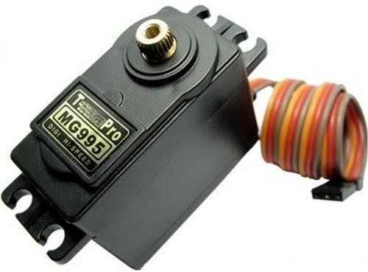

Fig No. 6.1 Servo Motor.

* Motors are used for controlling two dispensing gates and spinning feed plate.
* We choose servomotor instead of DC motor because our design requires accurate spinning angle for the food plate.
* Servo motor is paired with inner encoder to use position feedback to control its motion and final position accurately.
* More specifically, we choose the MG995 high speed metal gear dual ball bearing servo.
* It can provide up to 10 kgf.cm stall torque, which is more than enough for our physical design.



#### Ardunio Uno

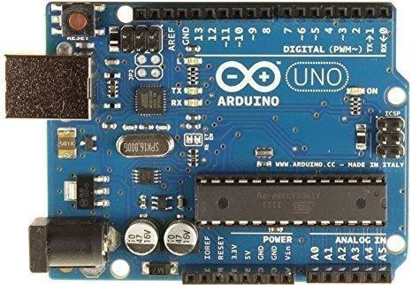

Fig No. 6.2 Arduino Uno

* Arduino Uno is a microcontroller board based on the ATmega328P.
* It has 14 digital input/output pins (of which 6 can be used as PWM outputs), 6 analog inputs, a 16 MHz quartz crystal, a USB connection, a power jack, an ICSP header and a reset button.
* It contains everything needed to support the microcontroller; simply connect it to a computer with a USB cable or power it with a AC-to-DC adapter or battery.



#### Bluetooth HC-05

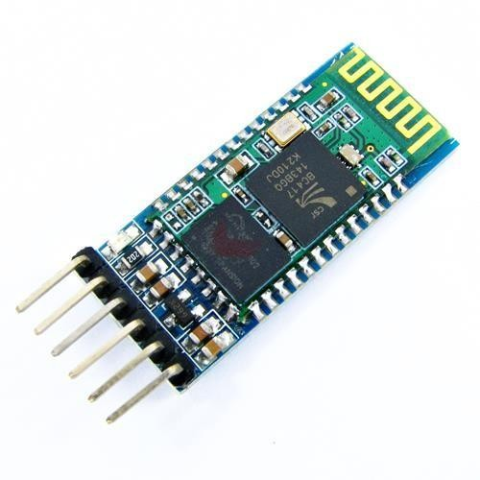

Fig. No. 6.3 Bluetooth HC-05

* It is used for many applications like wireless headset, game controllers, wireless mouse, wireless keyboard and many more consumer applications and has range up to 10m.
* It uses frequency-hopping spread spectrum (FHSS) radio technology to send data over air and uses serial communication to communicate with devices.

#### Pin configuration:

|  |  |  |
| --- | --- | --- |
| Pin number | Pin name | Description |
| 1 | Enable/Key | This pin is used to toggle between Data Mode (set low) and AT command mode (set high). By default it is in Data mode. |
| 2 | Vcc | Powers the module. Connect to +5V Supply voltage. |
| 3 | Ground | Ground pin of module, connect to system ground. |
| 4 | TX-  Transmitter | Transmits Serial Data. Everything received via Bluetooth will be given out by this pin as serial data. |
| 5 | RX-  Receiver | Receive Serial Data. Every serial data given to this pin will be broadcasted via Bluetooth. |
| 6 | State | The state pin is connected to on board LED, it can be used as a feedback to check if Bluetooth is working properly. |
| 7 | LED | Indicates the status of Module:   * Blink once in 2 sec: Module has entered Command Mode. * Repeated Blinking: Waiting for connection in Data Mode. * Blink twice in 1 sec: Connection successful in Data Mode. |
| 8 | Button | Used to control the Key/Enable pin to toggle between Data and command Mode. |



### Software Details

#### Arduino IDE

* The Arduino Integrated Development Environment - or Arduino Software (IDE) - contains a text editor for writing code, a message area, a text console, a toolbar with buttons for common functions and a series of menus.
* It connects to the Arduino hardware to upload programs and communicate with them.

### Circuit Diagram

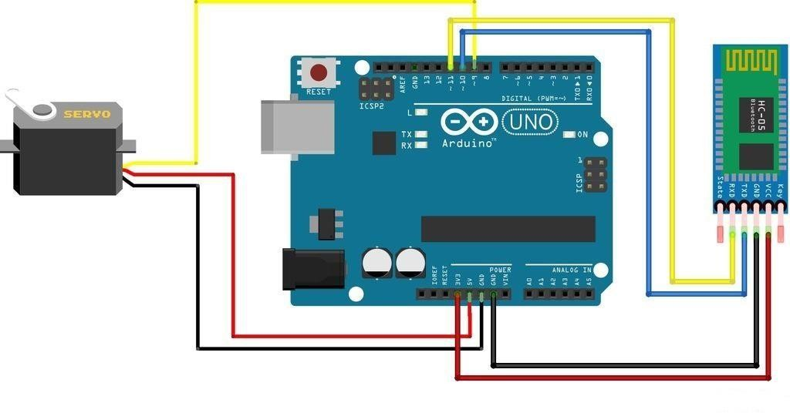

Fig. No. 6.4 Circuit Diagram.



# References

Website: https://www.arduino.cc Website: https://circuitdigest.com